Sterile DE 70% IN WFI (db)
140GSM Pre-Impregnated polyester wipes – ready to use
item 0141 (10 X 25 WIPES)

a 100% knitted polyester wipe, impregnated with denatured ethanol (de) 70% blend with Water for Injection (WFI) quality water, is a proven means for continual disinfection within highly controlled areas and high-grade cleanrooms (GMP grades A – B).

Polyester cleanroom wipes have Very low levels of particles and fibres, so they look to mitigate contamination risk. Their smooth, durable surface makes them ideal for wiping down sensitive equipment and surfaces without snagging or leaving fibres.

Sterile DE 70% in wfi quality water polyester wipes have the added benefit of being able to physically remove particles and spores while providing good disinfection against vegetative microbes.

- 100% HIGH-QUALITY Polyester wipe.
- laser-cut and sealed for reduced fibre contamination.
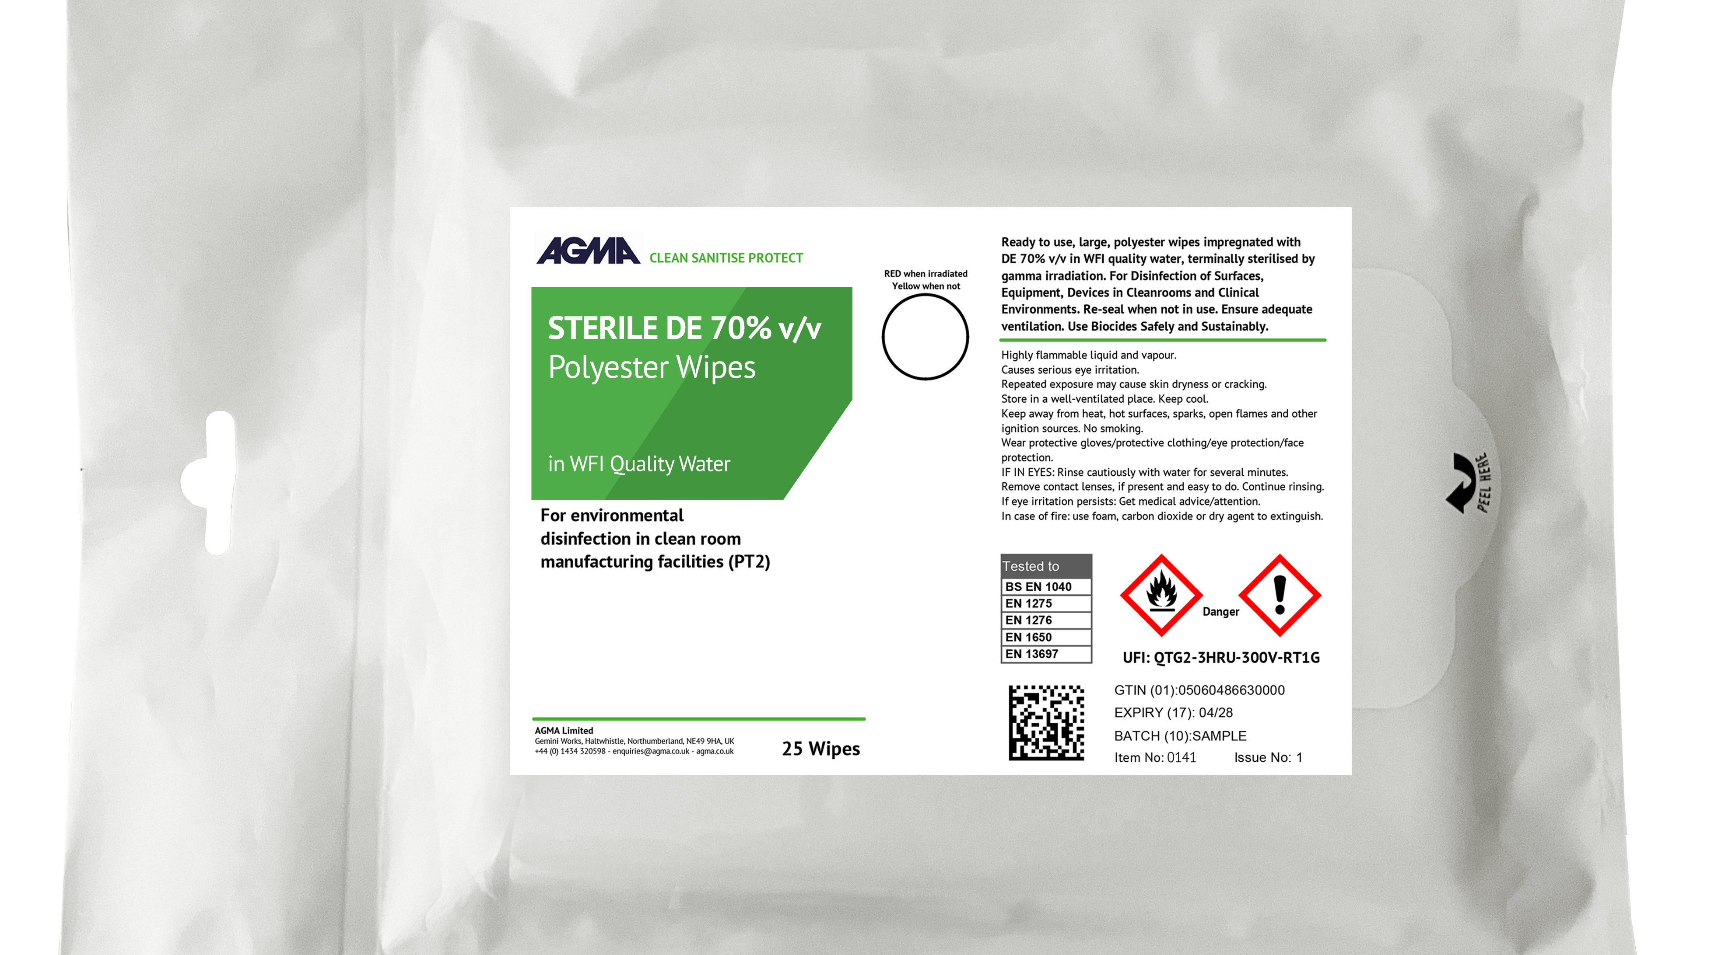
- for use in grade a/b cleANROOMS.
- Gamma irradiated for sterility.
- 0.2 micron filtered.
- 23cm x 23cm - 140GSM wipes.
- Re-sealable to prevent drying out.
- WFI quality water – High Purity Water.
- Manufactured in Grade C/D cleanrooms.
- Fully traceable with supporting ANALYSIS.
- DOUBLE-BAGGED (dB) plus box liner.
- 2-year shelf life.

DIRECTION FOR USE:
AGMA DE 70% IS MANUFACTURED TO HELP CLEANROOM OPERATORS MEET THE STANDARDS OF
ANNEX 1, FOR USE ON CLEANROOM EQUIPMENT AND HARD SURFACES.
ENSURE COMPLETE WETTING OF THE SURFACE. DO NOT USE TO TREAT SURFACES THAT ARE PARTICULARLY SENSITIVE TO ALCOHOL SUCH AS ACRYLIC GLASS.
ALWAYS CLOSE CONTAINER AFTER USE.

Use Biocides Safely. Always read the label and product information.

The information contained in this data sheet is accurate to the best of our knowledge and belief. No warranty is, however, given or
implied. Consult Agma Ltd. concerning all non-standard applications. Issue No. 1-06/26

